1.0 PURPOSE

To provide a procedure for measuring the retroreflectivity of road signs in the field.

2.0 SCOPE

This procedure refers to the use of a Retrosign® Reflectometer.

3.0 REFERENCES

- AS/NZS 1906.1, Retroreflective materials and devices for road control purposes Part 1: Retroreflective materials
- Retrosign ® Retroreflectometer user’s manual
- Master Specification Part 245, Supply of Materials for Pavement Marking

4.0 DEFINITIONS

Screened - A transparent process where colour is applied to reflective sheeting using screen printing techniques. AS/NZS1906.1 requires that screen printed materials have 70% of the retroreflectivity of sheeting of the corresponding class and colour.

EC Sheeting - A transparent overlay film. This can be reverse cut to apply a coloured background and a white legend or laser cut to produce a coloured symbol. AS/NZS1906.1 requires that EC overlay materials have 90% of the retroreflectivity of sheeting of the corresponding class and colour.

Retroreflective Sheeting - Retroreflective sheeting is cut out of the relevant coloured sheeting and stuck on to background sheeting.

5.0 APPARATUS AND MATERIALS

- Retroreflectometer
- Calibration cap
- Ladder for access to signs
- Cleaning cloths (both dry & damp)
- Atomizer containing water for sign cleaning
- Worksheets

6.0 PROCEDURE TO BE FOLLOWED

6.1 Calibration

Press “On” then “”. Mount the reference cap with the retroreflective surface in and trigger. Wait approximately three seconds for the instrument to collect the reading and calibrate itself.

Note: There is a locating lug to ensure the reference cap is correctly orientated

  - Preliminary

On arrival at the site note the sign details, ie. type, location, placement, visual condition including obvious physical damage (bent, graffiti, etc.). Record whether the legend is screened, EC coated or applied sheeting.

Record the information on date of manufacture, manufacturer and type of sheeting used that is normally stamped on the back of the sign.

Before cleaning the sign record measurements for the background and legends of the sign on the worksheet.

Clean the sign. The standard method is to dampen a cloth (Chux® super wipe or equivalent) wipe off the grime with broad sweeps rinsing cloth regularly. Then dry using another cloth. For new or very lightly contaminated signs a wipe with a dry cloth will suffice.

Note: It is essential that the sign is dry before measurements are taken.

6.3 Measurement

Calibrate the Retrosign® Reflectometer as set out in step 6.1.

Press the On/C button briefly to clear previous measurements.

Holding the instrument vertical (pistol grip directly vertical) and against the sign, press and release the trigger. A beep indicates the measuring cycle is starting. Approximately three seconds later a second beep indicates the measurement is complete. The displayed retroreflectivity number can either be recorded as an individual number or after a set of readings as a mean value, with all aberrant readings recorded.

Note: The orientation of the instrument does not significantly affect beaded sheeting (class 2 class 2A and older class 1 sheeting), however even a small change in angle will significantly affect microprismatic retroreflective materials (new class 1 and class 1W materials).

Note: If some areas appear to have been affected by particular degradation (such as with graffiti remover) these areas should be assessed and recorded separately.

Note: The colour of the sign may be tested in accordance with TP952 with the results recorded on the TP956 worksheet.

    - Measuring Background

Measure the retroreflective background in 5 or 6 locations (without clearing previous measurements) as shown in Appendix A. If any single reading is more than 50% above or below the adjacent readings the sign should be remeasured.

After each set of measurements Press the On/C button briefly to clear the display.

    - Measuring Sign Legends

Particular care must be taken to ensure that the aperture of the instrument covers only the area to be measured and does not include any of the background sheeting. Measure the legend in at least three places (examples shown in Appendix A).

If the legend width is less than 40mm and greater than 15mm the reducer aperture should be screwed on to the reflectometer. Readings taken with the reducer should be multiplied by 4 to obtain the correct retroreflectivity.

7.0 CALCULATIONS

Nil

8.0 PRECISION

No precision data available at this time.

9.0 REPORTS AND DOCUMENTATION

Completion of Field Measurement of Retroreflectivity TP956 worksheet.

Field Measurement of Retroreflectivity
TP956

Location: ……………………………………………………………………………………………
Road No: ……………………... | Date: ..…./….../……. | Sign No: …………
GPS: …………………………… | Tested By: ……………………..……………

Facing: | North | N/E | East | S/E | South | SW | West | N/W | North

Mounting: | Overhead | Left Shoulder | Right Shoulder | Median | Other

Stamped I/D
Manufacturer: ……………………………. | Stamped Date: ……………………….…
or Estimated Age: ……………Years

Condition: | Good | Bent | Corroded | Vandalised | Graffiti | Removed Graffiti

Sign Type: | Regulatory | Warning | Guide | Roadworks Information

Type of Sheeting: ……………………………. | Brand: ………………………………………..

Sign Area | Class | Colour | Overlay / Screened | Bead/  Microprism | Colour Measurement
 |  |  |  |  | Y | x | y
Legend 1
Legend 2
Background1
Background2

Sign Area | Uncleaned / Cleaned | Measurements |  |  |  |  |  | Mean
Sign Area | Uncleaned / Cleaned | 1 | 2 | 3 | 4 | 5 | 6 | Mean
Legend 1 | Uncleaned
Legend 1 | Cleaned
Legend 2 | Uncleaned
Legend 2 | Cleaned
Background1 | Uncleaned
Background1 | Cleaned
Background2 | Uncleaned
Background2 | Cleaned

Comments……………………………………………………………………………………………
…………………………………………………………………………………………………………
…………………………………………………………………………………………………………




Appendix A: Typical Road Sign Measurements Points


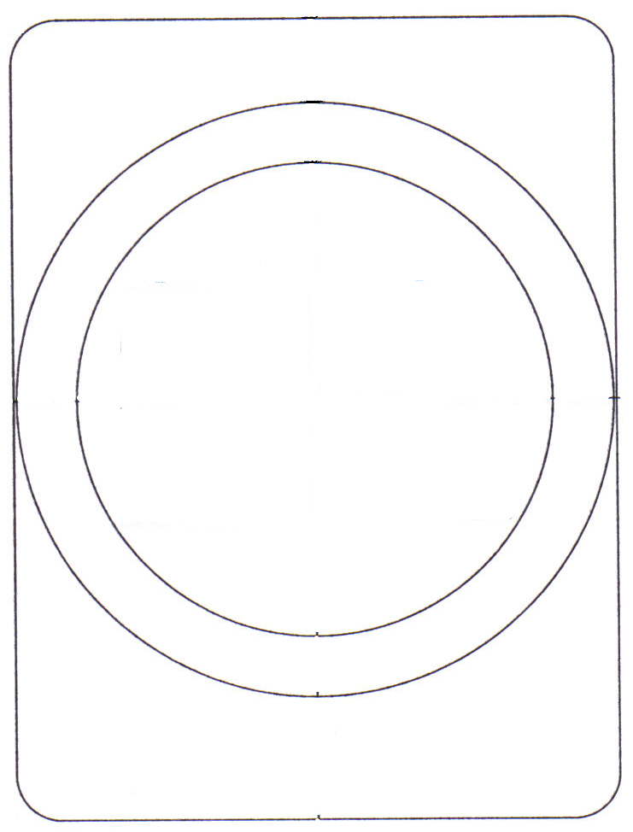

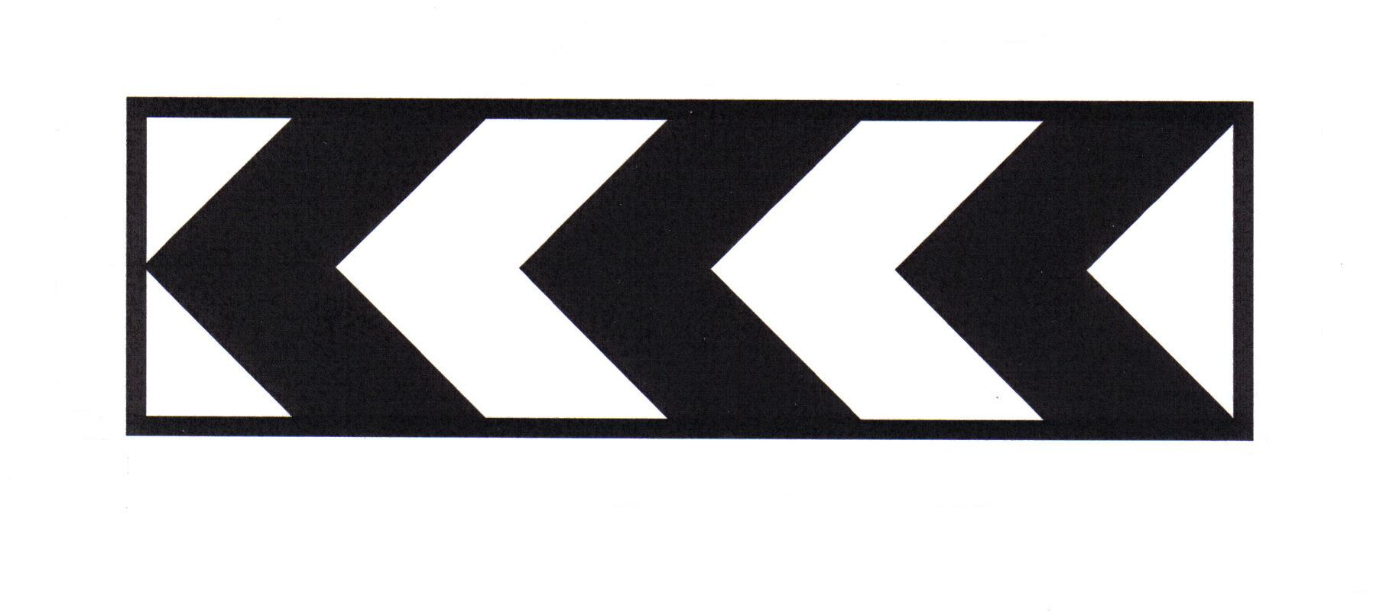

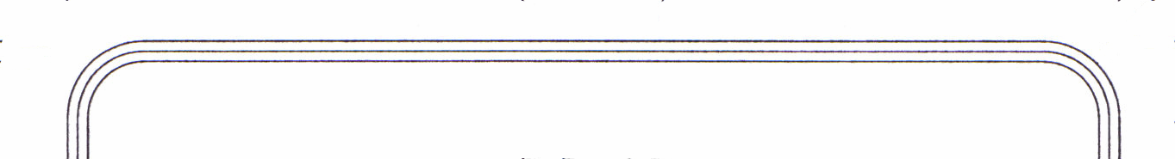

Suggested Measurement
Points
Background Points
Legend Points

