- PURPOSE

This procedure describes the process involved in measuring the deflection of a pavement as a known load is progressively applied to the pavement.

- REFERENCES

Deflectograph 4000, Operation and Maintenance Manual, WDM Ltd. Bristol. UK.

- DEFINITIONS

- Auto Centre Switch – Switch used to drive the measuring frame in centre position beneath vehicle, only available while steering enabled is selected. Switch must be held in until measuring frame is in position and turn off the key switch before release.
- Deflection Arm/ Deflection Beam/ Beam Arm – Connected to measuring box, with a cast skids at the tip.
- Deflection Bowl – A visual representation of the vertical displacement of a pavement surface under a standard axle load.
- Framelock – The framelock option is used to lock the measuring frame in place, while the Deflectograph is in motion, to prevent the measuring arms from being caught on pavement irregularities, eg. Railway tracks, edge of large patches, extreme cracking, etc. The framelock can be operated through the frame lock option on the computer screen or through a remote control that can be used outside of the Deflectograph.
- Guide Pin – The guide pin is positioned on the true centre line of the measuring frame allowing the frame to be aligned during forward motion with the aid of the steering mechanism.
- Measuring Frame/T Frame – A T shaped frame that is connected to the pavement surface in three locations at the outermost points. The measuring frame has a number of components connected to the frame including the deflection arm, measuring box and the guide pin.
- Measuring Box – There are two measuring boxes on the measuring frame, one on each side (left / right), attached to the measuring box is a deflection arm. Inside the measuring box there is a linear transducer, which translates the downward displacement of the deflection arm using the lever arm principle.
- Reference Marker – Markers that can be used to denote a feature as the Deflectograph travels, eg. Side roads, railway lines, etc.
- Cast Skids – The cast skid is a cast iron block that is attached to the end of the measuring arm & under the measuring box and it rests on the pavement surface during operation. Depending on distance travelled and roughness of the pavement the skid will have to be replaced before it wears down to the bolt heads.

- Steering Mechanism – The steering mechanism controls the position of the measuring frame to ensure that the measuring parts are in line with the rear wheels while the Deflectograph is in motion.
- Tyre Spike – Occurs when the measuring arm comes into contact with the rear wheels. Often the measuring arm is bent out of shape requiring it to be replaced before resuming testing.
- Winch Cable – A stainless steel cable connected to the winch at the front of the Deflectograph and the measuring frame. Replacement winch cables are required as the often deteriorate due to wear.
- A wider range of definitions are located in the operation and maintenance manual.

- APPARATUS AND MATERIALS

4.1 Apparatus

- Deflectograph and Ancillary Equipment
- Attenuator
- Temperature Measuring Equipment
- Pedometer
- Air Pressure Gauge
- Fluke Multi Meter
- Line Marking Paint
- Personal Safety Equipment
- Support Vehicle

  - Materials

- Wire Cables
- Beam Arms
- Cast Skids

- PROCEDURE

The procedure for the operation of the Deflectograph requires close attention to the manufacturers operating manual and this test procedure (See References).

A full list of Deflectograph Inspections can be found on, page 59, section 9.3, Deflectograph 4000, Operation and Maintenance Manual. Refer to Deflectograph Checklist (TP360-5) before vehicle is to leave base.

5.1 Calibration

The features of the Deflectograph that require calibration are detailed in Deflectograph 4000, Operation and Maintenance Manual, in Section 4.3.3.6 through to Section 4.3.3.8.

5.1.1 Daily Operation

Before daily operation of the Deflectograph a Check Beam Calibration is required. This is used to determine if the calibration of the beam arm is acceptable, instructions is detailed in Deflectograph 4000, Operation and Maintenance Manual, in Section 4.3.3.6.1.2. The results of the calibration are recorded on the form Calibration Beam Check TP360-3.

5.1.2 Full calibration shall be carried out annually or sooner if any changes are made to measuring boxes

5.1.3 Measuring Instrument Distance Calibration

This calibration is undertaken 6 monthly or as required, 4.3.3.6.1.1 page 25, on a measured piece of road 400 meter long and to an accuracy of 0.5m minimum. The calibration is to be undertaken when vehicle tyres wear or are changed. The results are to be recorded in the Equipment files. Refer to the WDM Deflectograph 4000 operation and Maintenance Manual for instructions.
The section of road to be used is along the North side of Montague Road between Main North and Port Wakefield Roads. The segment of road has been surveyed and marked by Surveying Services, DPTI.
After a calibration is done, a validation test run is done on the south side of Montague Rd between Main North and Port Wakefield Roads. A 1km segment of road has been surveyed and marked by Surveying Services, DPTI.

5.3 Computer

The procedure for the collection of data using the computer is detailed in the Deflectograph 4000, Operation and Maintenance Manual, in Sections 4.3.3.9 to 4.3.3.10.11.
On the Survey Details screen a unique survey number is entered in the PreData section, in the form of R 06XXXX (first two numbers is the year of testing eg. 06-2006) and the insert box is pressed. Also the temperature of the pavement is inserted in the PreData section in the form of T XX, with the temperature to the nearest whole number.

Important to Note:
- In section 4.3.3.10 Deflectograph Survey the check box on the computer screen Store Deflection Bowls must be checked, otherwise the deflection bowls are not saved and the survey has to be repeated.
- In section 4.3.3.10 Deflectograph Survey the Auto Framelock Enabled must not be checked, as the measuring frame will lock into position when the survey starts. Therefore data is not collected until the Auto Framelock Enabled is disengaged.

5.4 Beam Operation

The lifting and lowering of the measuring frame is detailed in the Deflectograph 4000, Operation and Maintenance Manual, in Sections 6.1 and 6.2.
Note: The maximum running time for the electric motor controlling the hydraulic pump is 5 minutes. After 5 minutes the electric motor has to be turned off and allow cooling before operations can continue.
Note: Double check that both sides of the measuring frame are correctly lowered or lifted and secured in the proper positions before moving vehicle.

5.5 Data Processing

The data collected in the Deflectograph needs to be processed through a program called TSD reformat.exe. This program is available on the Deflectograph computer and on selected staff computers. If data is to be processed through a computer outside of the Deflectograph the files with following file extensions .bwl, .txt and .def are required for each survey.
On the start up screen there is a box that can be checked if the data has been collected on the right carriageway, this reverses the data. After data reversal (if required) the Australian Deflectograph Data Reformat box is pressed and the .bwl file is located and converted to a file with the extension name of .rnp.
The converted file is then processed through a program called ADDVS3, available only to selected staff, which produces a print out similar to form TP360-4.

  - Data handling and Storage

The data collected shall be transferred to the DPTI computing network and stored for future reference. Back up systems in the form of the network backups and periodic CD copies shall be undertaken and maintained to DPTI requirements.

- PRECISION

Not Available

- DOCUMENTATION

Documents and forms to be completed:

- Deflectograph Work Sheets TP360-1 & TP360-2
- Beam Check TP360-3
- Output Print TP360-4
- Deflectograph Checklist TP360-5

Department of Planning, Transport & Infrastructure
19 Bridge Road Walkley Heights Ph (08) 8260 0320, PO Box 1533, Adelaide SA 5001
Technical Services Group
Procedure
DEFLECTOGRAPH WORK SHEET
TP360
ROAD: |  |  |  |  |  |  |  |  |  |  |  |  |  |  |  |  |  |  | RN:
SECTION:
DEFLECTOGRAPH RUN NUMBER:
Seal Type: |  |  |  |  | C/Way: |  | N |  | S |  | E |  |  | W |  | Date: / /
Shoulder Sealed: |  |  | Y | N | D.O.T: |  | N |  | S |  | E |  |  | W |  | Start Ch:
Median: |  |  | Y | N | Lane: |  | 1 |  | 2 |  | 3 |  |  | 4 |  | End Ch:
Kerb: |  |  | Y | N | Code: |  | L |  |  | R |  | U |  |  |  | Char. Factor: |  | 1.3 |  |  |  | 1.65 |  |  | 2.0
OWP Offset: |  |  |  |  | Crew: |  |  |  |  |  |  |  |  |  |  | Stats Ref:
IWP Offset: |  |  |  |  |  |  |  |  |  |  |  |  |  |  |  | Page of
EVENT NO. |  | CHAINAGEMetres |  | ROAD FEATURES |  |  |  |  |  |  |  |  |  |  |  |  |  |  |  |  | TEMPERATURE
 |  |  |  |  |  |  |  |  |  |  |  |  |  |  |  |  |  |  |  |  | Surface
1
2
3
4
5
6
7
8
9
10
11
12
13
14
15
16
17
18
19
20
21
22
23
24
25
COMMENTS:
 |  |  |  |  |  | Start |  | End |  |  |  |  | Hours |  |  |  |  |  |  | Signed |  |  |  | Date
 | Set Up Paperwork |  |  |  |  |  |  |  |  |  |  |  |  |  |  |  | Processed
 | Pre-checks |  |  |  |  |  |  |  |  |  |  |  |  |  |  |  | Database
 | Travel to site + testing |  |  |  |  |  |  |  |  |  |  |  |  |  |  |  | Checked
 | Process |  |  |  |  |  |  |  |  |  |  |  |  |  |  |  | Uploaded
 | Check |  |  |  |  |  |  |  |  |  |  |  |  |  |  |  | Knet
 | Form TP360-1, Revn.1.7 |  |  |  |  |  |  |  |  |  |  |  |  |  |  |  | Sent
Department of Planning, Transport & Infrastructure
19 Bridge Road Walkley Heights Ph (08) 8260 0320, PO Box 1533, Adelaide SA 5001
Technical Services Group
Procedure

DEFLECTOGRAPH WORK SHEET
TP360

ROAD: |  |  |  |  |  |  |  |  |  |  |  |  | RN:
SECTION:
DEFLECTOGRAPH RUN NUMBER:
Seal Type: |  |  |  | C/Way: | N | S |  | E |  | W | Date: / /
Shoulder Sealed: |  | Y | N | D.O.T: | N | S |  | E |  | W | Start Ch:
Median: |  | Y | N | Lane: | 1 | 2 |  | 3 |  | 4 | End Ch:
Kerb: |  | Y | N | Code: | L |  | R |  | U |  | Char. Factor: | 1.3 |  |  | 1.65 |  | 2.0
OWP Offset: |  |  |  | Crew: |  |  |  |  |  |  | Stats Ref:
IWP Offset: |  |  |  |  |  |  |  |  |  |  | Page of
EVENT NO. | CHAINAGE  Meters |  | ROAD FEATURES |  |  |  |  |  |  |  |  |  |  | TEMPERATURE
EVENT NO. |  |  |  |  |  |  |  |  |  |  |  |  |  | Surface
26
27
28
29
30
31
32
33
34
35
36
37
38
39
40
COMMENTS:

NOTE: There are only 40 reference markers available for each survey.

Form TP360-2, Revn.1.7
Department of Planning, Transport & Infrastructure
19 Bridge Road Walkley Heights Ph (08) 8260 0320, PO Box 1533, Adelaide SA 5001
Technical Services Group
Procedure

BEAM CHECK
TP360

Dial Gauge Identification: 031 / _ _ _
Date: _ _ / _ _ / _ _ _ _
Time: _ _ : _ _ am/pm
Computer Operator:…………………………………….………..……
Gauge Operator:…………………………………….…………………

WDM Deflectograph 4000 ‘Operation and Maintenance Manual’ (09/02/2006)
Part 4.3.3.6.1.2 states:

All results should be within ±0.01mm of the expected displacement, (if not retry check beam).
If still not within ±0.01mm of the expected displacement, a beam arm recalibration will be required.

Passenger “As Found”

Beam Tip Input Level (mm/100) |  | 10 | 20 | 30 | 40 | 50 | 60 | 70 | 80 | 90 | 100 | 200
Attempt | 1
Attempt | 2
Attempt | 3

Driver “As Found”

Beam Tip Input Level (mm/100) |  | 10 | 20 | 30 | 40 | 50 | 60 | 70 | 80 | 90 | 100 | 200
Attempt | 1
Attempt | 2
Attempt | 3

Form TP360-3, Revn.1.7
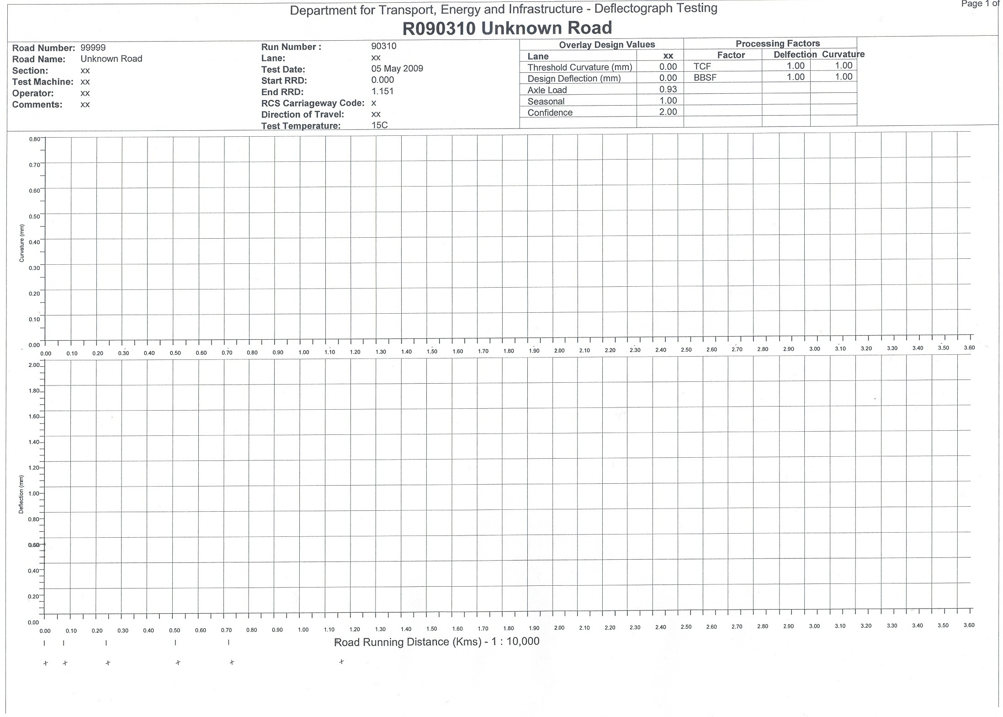

Form TP360-4, Revn 1.7

Department of Planning, Transport & Infrastructure
19 Bridge Road Walkley Heights Ph (08) 8260 0320, PO Box 1533, Adelaide SA 5001
Technical Services Group
Procedure

DEFLECTOGRAPH CHECKLIST
TP360

DATE / / BEFORE DEPARTING FROM BASE
1 | Has beam check been done? | Yes / No
2 | Weekly tyre pressures been checked? (770 ± 20kpa) | Yes / No
3 | Pedometer and line marking paint in vehicle? | Yes / No
4 | Thermometer in vehicle? | Yes / No
5 | Test sheets, maps and USB in vehicle? | Yes / No
6 | Operations and maintenance manuals in vehicle? | Yes / No
7 | Spare wire cable, beam arms and cast skids in vehicle? | Yes / No
8 | Check the first aid kit? | Yes / No
9 | Do you have your personal bag with PPE? | Yes / No
10 | Attenuator attached correctly & tail lights/indicators work? | Yes / No
11 | Check flashing lights and signboard are working? | Yes / No
12 | Silicone spray the steering arm rail and the arrester gear springs? | Yes / No
13 | Silicon spray and also check measuring cable freedom to beam? | Yes / No
14 | Clean frame sensors with soft cloth and window cleaner? | Yes / No
15 | Check winch cable for fraying? | Yes / No
16 | Check attenuator trailer tyre pressures? (45psi) | Yes / No
17 | Check wear marks on skid shoes? | Yes / No
18 | General visual check to see if anything is broken? | Yes / No

Today’s Crew Members:
Traffic Control Company:
Comments on problems/faults:

Form TP360-5, Revn.1.7

