Purpose
The purpose of the Accreditation Self-Assessment is to prepare Lead Agencies for accreditation and seek feedback from the Accreditation Unit prior to the formal application process under the Accreditation Framework for Planned Small Construction Projects (the Framework).
Scope
The Accreditation Self-Assessment process, shown in Figure 1, will assist Lead Agencies in understanding their own capability and capacity to manage and mitigate risk to government in accordance with PC028. It will also support an efficient application and assessment process.
The Accreditation Self-Assessment has been aligned to the mandatory assessment criteria for Lead Agency accreditation and outlines the required artefacts to be provided as supporting evidence, through the application process.
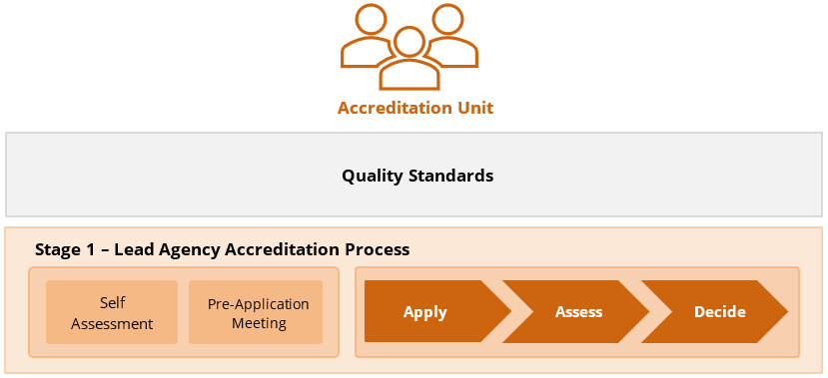

Figure 1: Stage 1 Lead Agency Accreditation Process – Self Assessment
Process
How to Complete the Accreditation Self-Assessment
Step 1 Complete Accreditation Self-Assessment
The Lead Agency is to complete the all sections of the AP-03 Accreditation Self-Assessment Checklist. The Lead Agency will then collate required artefacts as supporting evidence and;
Step 2 Request a Pre-Application Meeting
Upon completion of Step 1, the Lead Agency is to submit a completed AP-02 Pre-Application Meeting Request, AP-03 Accreditation Self-Assessment Checklist and any preliminary supporting evidence to the Accreditation Unit.
Step 3 Attend Pre-Application Meeting
Upon completion of Step 2, the Accreditation Unit will arrange a pre-application meeting for the Lead Agency to present its Accreditation Self-Assessment and artefacts and will provide feedback, in preparation for lodgement of a formal application.

