Having an Automated External Defibrillator (AED) nearby when needed

Workers at the Ovingham Level Crossing Removal project provided life-saving assistance to a member of the public who was noticed lying unconscious near the project worksite.
After calling emergency services, cardiopulmonary resuscitation (CPR) was commenced, and an AED from the project’s nearby safety station was retrieved and deployed.
Approximately 10 minutes passed before an ambulance and paramedics arrived.

Giving immediate CPR and using an AED early on can greatly increase chances of survival, as was the case in this event.

Each year, more than 30,000 Australians suffer a cardiac arrest. If it happens outside of hospital, chances of surviving are less than 1 in 10.

Uncorrected, cardiac conditions (ventricular tachycardia, ventricular fibrillation, asystole) can rapidly lead to irreversible brain damage and death once cardiac arrest takes place.

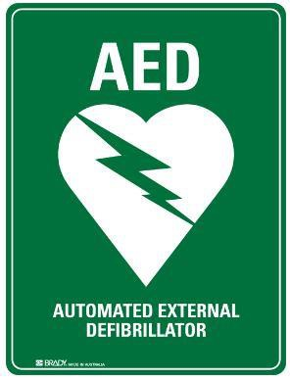
After approximately three to five minutes in cardiac arrest, irreversible brain/tissue damage may begin to occur.

For every minute that a person in cardiac arrest goes without being successfully treated (by defibrillation), the chance of survival decreases by 7 percent per minute in the first 3 minutes and decreases by 10 percent per minute as time advances beyond 3 minutes.

Special mention to Josiah Condon and fellow workers for their quick action and assistance at a time it was most needed.
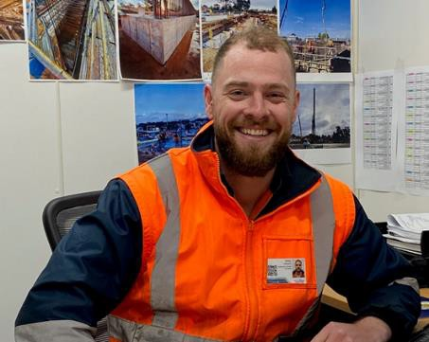

The Department for Infrastructure and Transport’s Master Specification now requires construction contractors to ensure that sufficient AEDs are available such that a person suffering a sudden cardiac arrest can be delivered a shock within three to five minutes of collapsing, and that workers are aware of their location(s).

