GEOSPATIAL SERVICES
Standards & Operational Procedures

LOCATING SEQUENTIAL STRINGS – Lights and Gantries

CODE | LT
DESCRIPTION | Top of sign
MODEL | XSURVEY
TINNABLE | NO
DIRECTIONAL
LOCATION INFORMATION
COMMENTS | Locate PSPA point string for steel poles
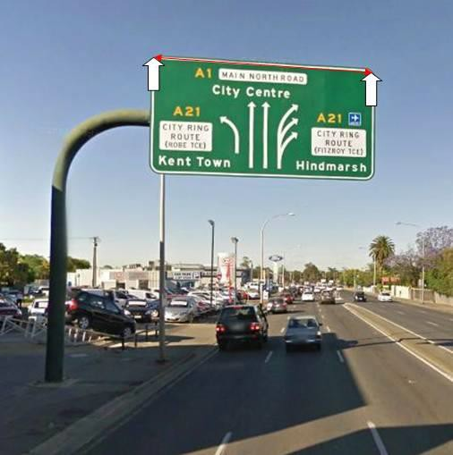

CODE | LU
DESCRIPTION | Bottom of sign
MODEL | XSURVEY
TINNABLE | NO
DIRECTIONAL
LOCATION INFORMATION
COMMENTS | Locate PSPA point string for steel poles
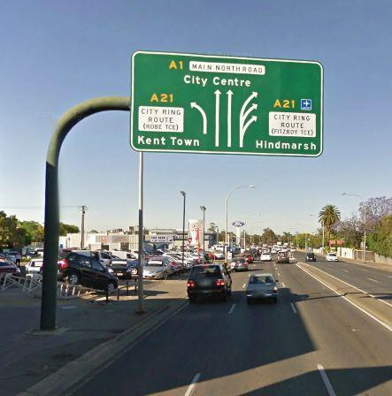

CODE | OR
DESCRIPTION | Lighting Outreach
MODEL | SERVICES ASSET
TINNABLE | NO
DIRECTIONAL
LOCATION INFORMATION | Locate at base and extent of spigot
COMMENTS | See below for examples
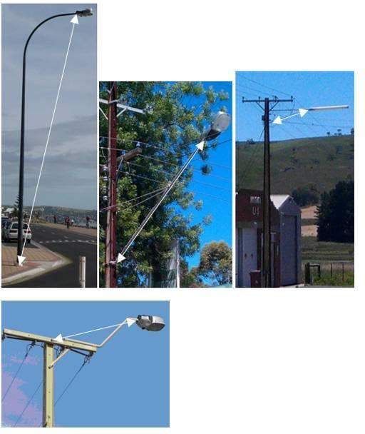

NOTE: Bases of lights are coded as either, Steel Pole (PLPO) , Wooden Pole (PWPA) or Stobie Pole (PSTA)

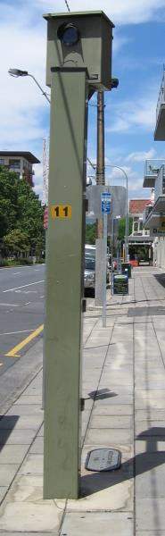

CODE | PCAM
DESCRIPTION | Camera/ CCTV
MODEL | SERVICES ASSET
TINNABLE | NO
DIRECTIONAL
LOCATION INFORMATION
COMMENTS | Locate at bottom centre
FIG 1.0 FIG 1.3

FIG 1.1
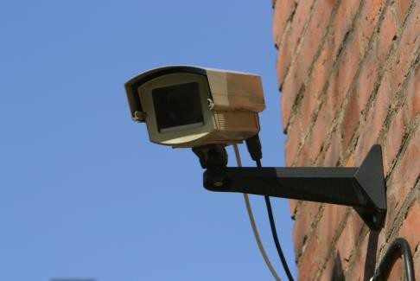

FIG 1.2
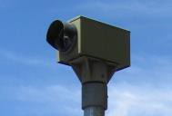

NOTE: survey base of Speed detection cameras as pole steel (PSPA)

CODE | PCOM
DESCRIPTION | Combination Light and Traffic Light
MODEL | SERVICES ASSET
TINNABLE | NO
DIRECTIONAL
LOCATION INFORMATION | Locate at base
COMMENTS
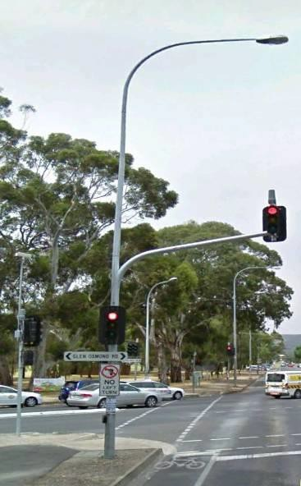

CODE | PLPO
DESCRIPTION | Lighting Pole
MODEL | SERVICES ASSET
TINNABLE | NO
DIRECTIONAL
LOCATION INFORMATION | Locate at base
COMMENTS
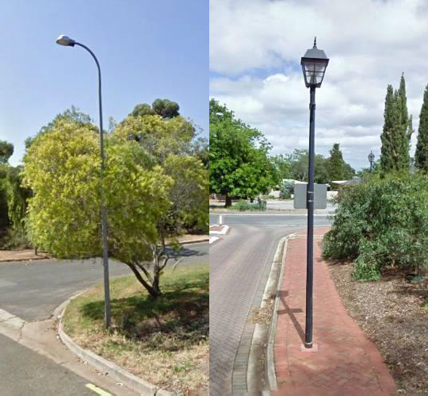

CODE | PPLI
DESCRIPTION | Lighting Luminare
MODEL | SERVICES ASSET
TINNABLE | NO
DIRECTIONAL
LOCATION INFORMATION
COMMENTS | Locate at bottom centre
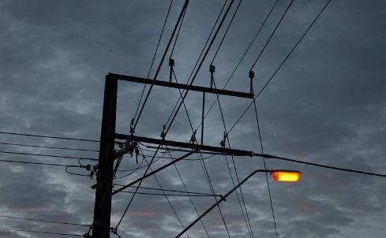

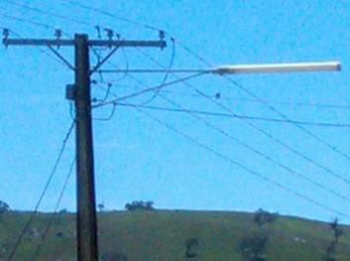

CODE | PTLL
DESCRIPTION | Traffic Light
MODEL | SERVICES ASSET
TINNABLE | NO
DIRECTIONAL
LOCATION INFORMATION | Locate at base
COMMENTS
