Department for Infrastructure and Transport

APPLICATION FOR:
Preferred Supply Arrangement – Safety Barrier (PSASB)
(PSA No. 20C610)

CONTACT FOR FURTHER INFORMATION | E-mail: DIT.PSASB@sa.gov.au
CLOSING | Applications must be submitted electronically at DIT.PSASB@sa.gov.au

INSTRUCTIONS

General
Suppliers (Applicants) wishing to apply for 20C610 Preferred Supply Arrangement – Safety Barrier with the Department for Infrastructure and Transport (the Department) must fill out this Application Form and attach the information requested.
- Complete the Application Form and save as a .docx or .pdf file (without these instructions).
- Save the attachments as .pdf files. Where the files are small, they should be combined so that an absolute maximum of 10 files in total are submitted. Strictly follow the numbering system in this form when preparing the attachments.
Further guidance on applying for membership can be found in the Application Guidelines: 20C610 Preferred Supply Arrangement - Safety Barrier.
The submission of an Application is deemed agreement by the Applicant to the terms and conditions of the Guidelines.

Submitting the Application
Applications must:
- include all documentation outlined in this Application Form, together with any other supporting technical or financial information;
- include file names which clearly indicate the applicable section numbers of this application that are addressed in the file; and be submitted electronically at www.tenders.sa.gov.au
- with the following subject line:
NEW APPLICATION – 20C610 Preferred Supply Arrangement – Safety Barrier
Do not submit a hard copy.
Do not submit information not specifically requested in this Application.
Enquiries may be directed to contacts on front page of this Application Form.

Publication of Details
Once accepted in the PSASB, the contact details provided in this Application Form will be published on the following internet site: https://dit.sa.gov.au/contractor_documents/prequalification.
It is the Applicant’s responsibility to ensure that the contact details provided are up to date.

MANDATORY CRITERIA
As specified in the Guidelines, the Mandatory Criteria and Non Price Criteria for assessment for membership to the PSACB are as follows:
Table 1 – Mandatory Criteria
Mandatory Criteria
Certificate of Currency for Workers Compensation Insurance Certificate (RTWSA)  (Refer to Schedule 2) | Acceptable/Not Acceptable
Industry Advocate Statement of Intent  (Refer to Schedule 3) | Acceptable/Not Acceptable
SA Building Work Contractor’s Licence(s) to perform works in accordance with the requirements of Consumer and Business Services SA. The license category endorsement of ‘Civil Construction’ or ‘Any Building Work’ or ‘Metal Fabricated Production Installation’, has been deemed the minimum requirement  (Refer to Schedule 4) | Acceptable/Not Acceptable
Australian Government National Building Code 2016 Declaration of Compliance for any works containing Federal Government funding Streams  (Refer to Schedule 5) | Acceptable/Not Acceptable
Provision of company signed acceptance of the PSASB contract and related Application documents  (Refer to Schedules 1 and 6) | Acceptable/Not Acceptable
Satisfactory financial assessment  (The Department will arrange for a financial assessment to be undertaken via a third party provider during the Application evaluation process) | Acceptable/Not Acceptable

Table 2 – Non Price Criteria assessment for qualification to the PSASB.

Description | Assessed
Demonstrated commercial compliance and technical capability including examples of safety barrier installations for Government Authorities within the last 12 months including:  - Steel beam  - Box beam  - Wire rope  - Bridge barrier  (Refer to Schedule 7) | Satisfactory/  Unsatisfactory
Experience of company personnel including specific details of completed safety barrier works within the last 12 months  (Refer to Schedule 8) | Satisfactory/  Unsatisfactory
Details of Plant and Equipment to be used on work orders  (Refer to Schedule 9) | Satisfactory/  Unsatisfactory
Supply of Management Plans demonstrating compliance to DIT Master Specifications for the following:  - Quality  - Safety  - Environmental  - Covid 19  (Refer to Schedule 10) | Satisfactory/  Unsatisfactory

SCHEDULE CHECKLIST FOR APPLICATION

For each item below, please tick the box to indicate that the Schedule has been:
- completed; and
- included with your returned Application.
Schedule No. | Schedule | Included
1 | Applicant Information | ☐
2 | Insurances - Certificate of Currency for RTWSA | ☐
3 | Statement of Intent for Industry Participation Plan (SAIPP) | ☐
4 | SA Building Work Contractor’s Licence(s) | ☐
5 | Australian Government National Building Code 2016 Declaration of Compliance | ☐
6 | GC21 Terms and Conditions and Master Specification Compliance | ☐
7 | Company Experience | ☐
8 | Company Personnel | ☐
9 | Plant & Equipment | ☐
10 | Management Plans | ☐

APPLICATION FORM
Schedule 1. Applicant Information
Trading Name
Registered Name
ACN
ABN
Address of registered office
Place of business in South Australia (if relevant)
Type of entity (e.g. company, trust, partnership, sole trader, other)
Key Personnel (e.g. directors, chief executive officer, principal of business etc.)
Telephone
Website

Contact Details
Contact Person
Position
Address
Postal address
E-mail
Telephone

Conflict Of Interest
You must provide details of any actual or perceived interests, relationships or clients which may cause a conflict of interest or potential conflict of interest, and actions to prevent or manage the conflicts of interest.

Schedule 2: Insurance-Certificate of Currency for Return to WorkSA

Applicants must attach to this Schedule a Certificate of Currency or Registration evidencing that the Applicant holds workers compensation insurance with Return to Work SA.

Schedule 3: Statement of Intent for Industry Participation Plan (SAIPP)
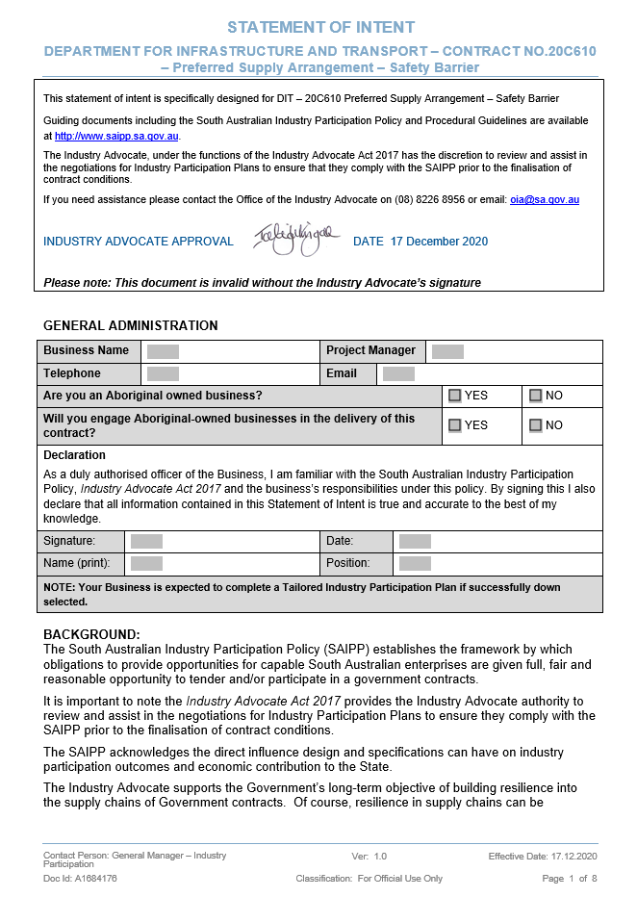
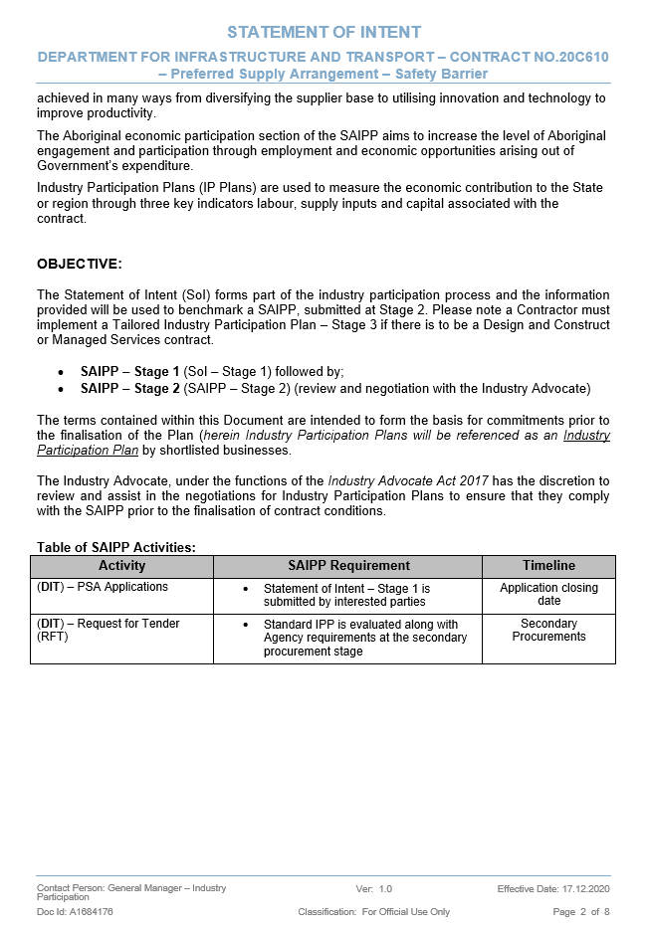
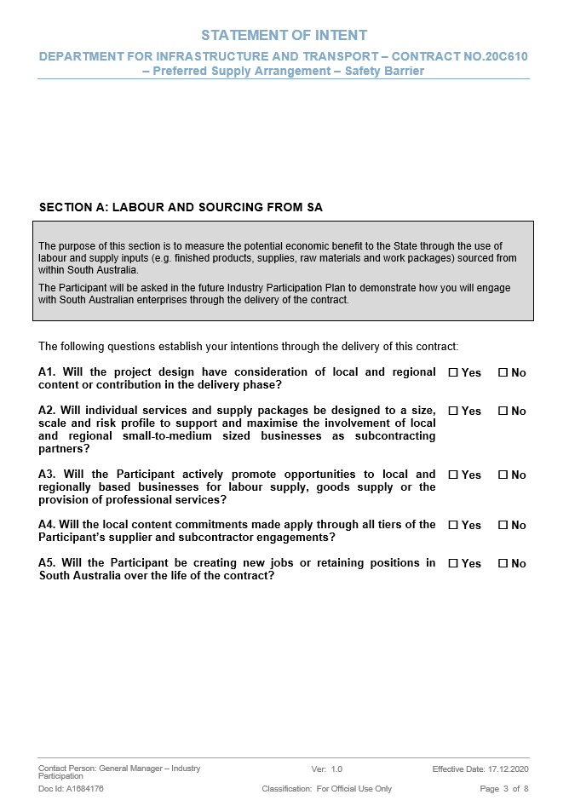
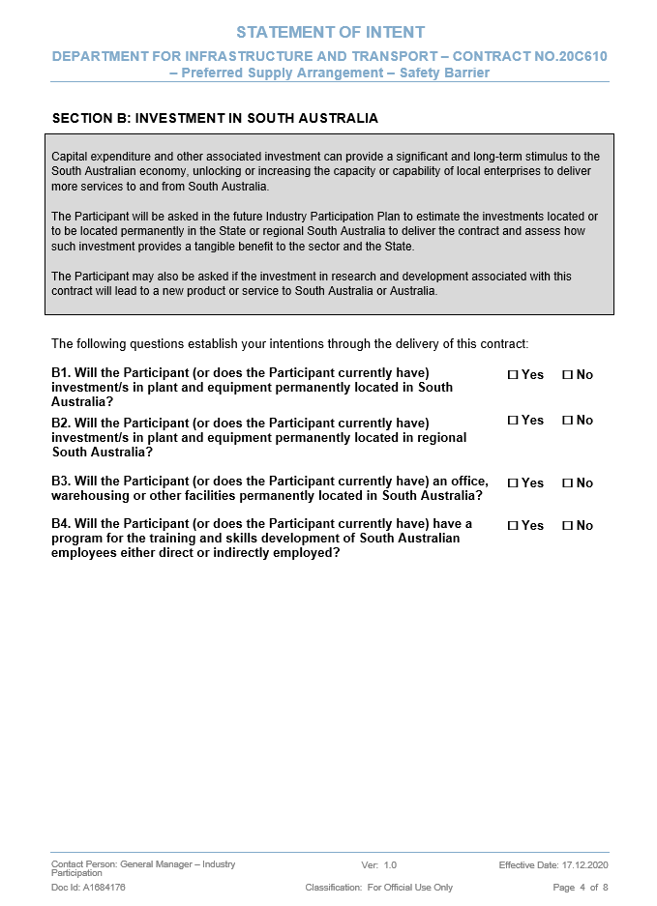
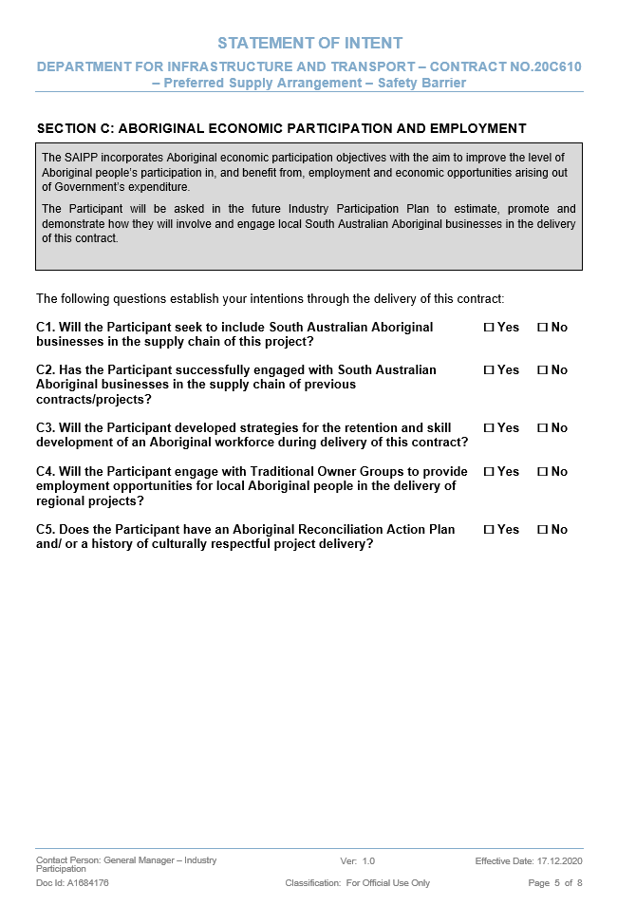
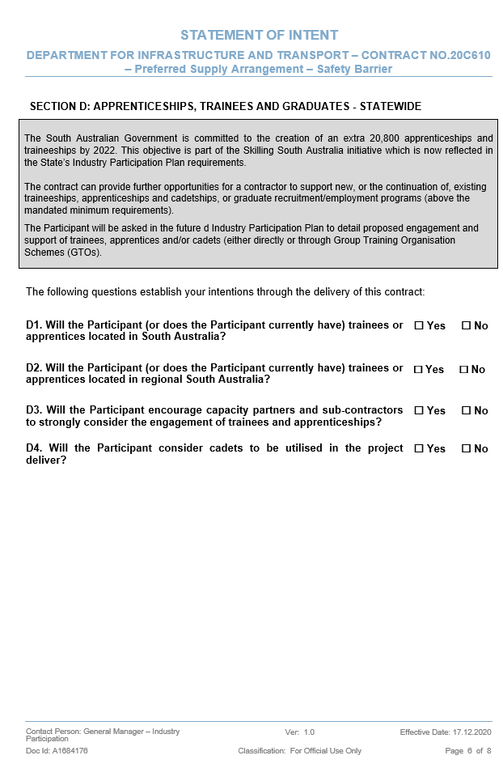
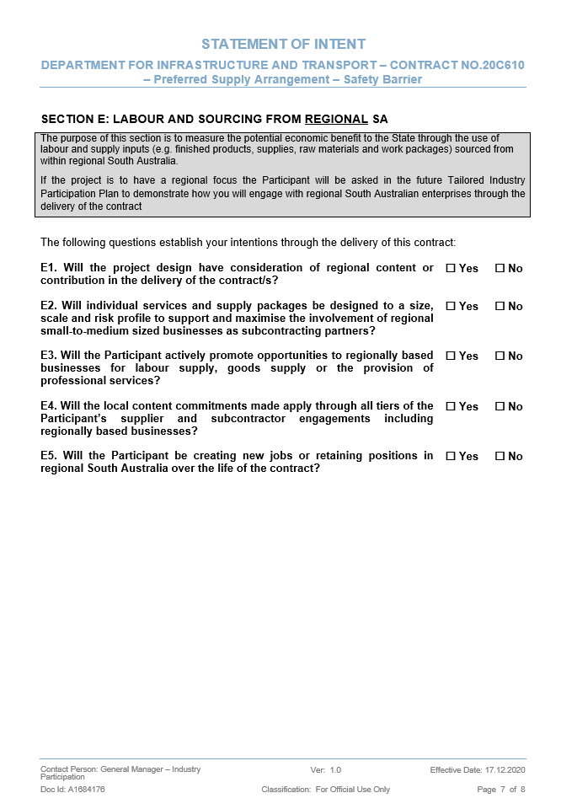
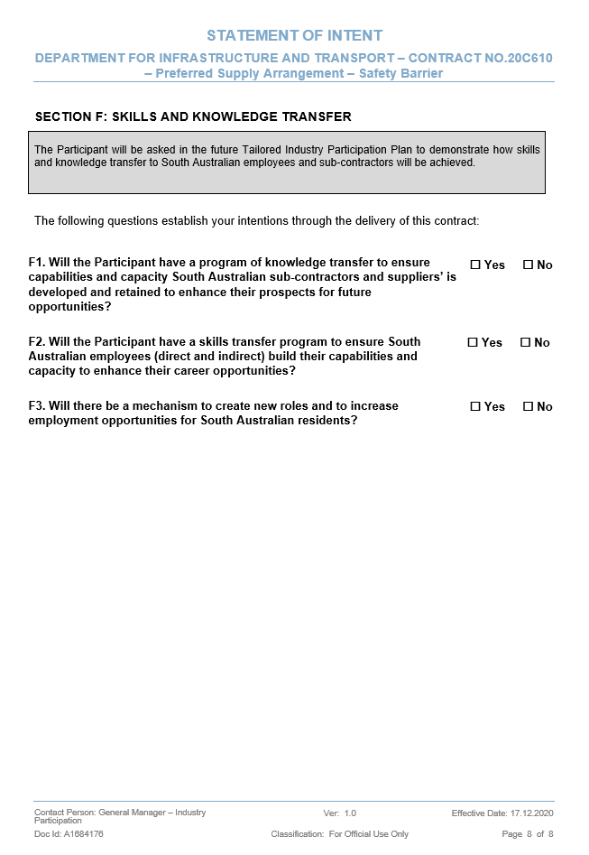
Schedule 4: SA Building Work Contractor’s Licence(s)

Applicants must attach evidence demonstrating that the Applicant holds the required SA Builder’s Licence issued by Consumer and Business Services SA www.cbs.sa.gov.au (refer to the Guidelines and Mandatory Criteria for further information).

You can create an application for a SA Building Work Contractor’s licence at the link below:
https://www.sa.gov.au/topics/business-and-trade/licensing/building-and-trades/building-work-contractor-s-licence
Should you have any questions relating to the application process, please do not hesitate to contact Occupational licensing on 131 882 (Option 4) or via email occupational@sa.gov.au
.

Schedule 5: Australian Government National Building Code 2016 Declaration of Compliance

Code for the Tendering and Performance of Building Work 2016

5.1 Building Code

- In these clauses:

ABCC | means the body referred to in subsection 29(2) of the Act.
Act | means the Building and Construction Industry (Improving Productivity) Act 2016.
Building Code | means the Code for the Tendering and Performance of Building Work 2016, which is available at https://www.legislation.gov.au/Details/F2017C00668 .
Building Work | has the same meaning as in subsection 3(4) of the Building Code.
Commonwealth Funded Building Work | means Building Work in items 1-8 of Schedule 1 of the Building Code.
Enterprise Agreement | has the same meaning as in the Fair Work Act 2009.
Exclusion Sanction | has the same meaning as in subsection 3(3) of the Building Code.
Related Entity | has the same meaning as in subsection 3(2) of the Building Code.
Works | means Commonwealth Funded Building Work that is the subject of this Request for Tender.

- The Building Code applies to the Works.
- You must comply with the Building Code and meet the eligibility requirements set out in section 23 of the Building Code at the time of your Application.
- As part of your Application, you must submit:
    - a signed “Declaration of Compliance” which is attached to this Application; and
    - the further information outlined in Attachment A to the “Declaration of Compliance”.
- You will only enter into a subcontract in relation to the Works if:
    - you and your Related Entities are not covered by an Enterprise Agreement that does not meet the requirements of section 11 of the Building Code;
    - you are not subject to an Exclusion Sanction or excluded from undertaking work funded by a state or territory government unless approval to do so is provided by the ABC Commissioner;
    - you will only use products in relation to the Works that comply with the relevant Australian standards published by, or on behalf of, Standards Australia.
- The Principal will exclude Applicants from further consideration if at any time before a contact is executed in relation to the Works the applicant considers that they do not comply with the requirements in clause 4.1 (v).

Applicants can find further information about the Building Code 2016 at www.abcc.gov.au.

Further information about Workplace Relations Management Plans can also be found at https://www.abcc.gov.au/building-code/contractors/tendering/workplace-relations-management-plans-wrmp

Building Code 2016 - Declaration of Compliance

Applicants must:
- Complete and return the Building Code 2016 Declaration of Compliance; and
- Attach to this Schedule 5 evidence demonstrating compliance by providing an ABCC Self-Assessment A form, ABCC Letter of compliance or alternate forms as accepted by ABCC, refer link below.

https://www.abcc.gov.au/building-code/contractors/eligibility-tender

20C610 - PSASB
Name of Applicant:
ABN:
ACN:
1.1.1 In this Declaration of Compliance:
ABCC | means the body referred to in subsection 29(2) of the Act.
ABC Commissioner | means the Australian Building and Construction Commissioner referred to in subsection 15(1) of the Act.
Act | means the Building and Construction Industry (Improving Productivity) Act 2016.
Building Code | means the Code for the Tendering and Performance of Building Work 2016, which is available at https://www.legislation.gov.au/Details/F2017C00668.
Building Contractor | has the same meaning as in the Act.
Building Industry Participant | has the same meaning as in the Act.
Building Work | has the same meaning as in subsection 3(4) of the Building Code.
Commonwealth Funded Building Work | means Building Work in items 1-8 of Schedule 1 of the Building Code.
Enterprise Agreement | has the same meaning as in the Fair Work Act 2009.
Exclusion Sanction | has the same meaning as in subsection 3(3) of the Building Code.
Related Entity | has the same meaning as in subsection 3(2) of the Building Code.
Sub-subcontractor | means a Building Contractor or Building Industry Participant who the Subcontractor has entered, or proposes to enter, into a sub-subcontract with to undertake any of the Works.
Works | means the Commonwealth Funded Building Work that is proposed to be the subject of a contract with the successful Applicant.

1.1.2. The Applicant acknowledges that it and its Related Entities must comply with the Building Code in relation to all Building Work described in Schedule 1 of the Building Code for which an expression of interest or request for tender (however described) is called on or after the date that the Building Code commenced, being 2 December 2016, and, should it be the successful Applicant, in relation to the Works.
1.1.3. The Applicant undertakes to ensure that it and its subcontractors, should it be the successful Applicant, comply with the Building Code.
1.1.4. The Applicant acknowledges the powers and functions of the ABC Commissioner and the ABCC under the Act and the Building Code and undertakes to ensure that it and its Sub-subcontractors will comply with any requests made by the ABCC and the ABC Commissioner within those powers and functions, including but not limited to requests for entry under section 72 of the Act, requests to interview any person under section 74 of the Act, requests to produce records or documents under sections 74 and 77 of the Act and responding to requests for information concerning matters relating to the Building Code under subsection 7(c) of the Building Code.
1.1.5. The Applicant declares that where it proposes to subcontract any of the Works, should it be the successful Applicant, it will:
a. not enter into a subcontract with a subcontractor who:
i. is covered by, or has Related Entities covered by, an Enterprise Agreement that does not meet the requirements of section 11 of the Building Code;
ii. is subject to an Exclusion Sanction; or
iii. unless approved otherwise by the ABC Commissioner, is excluded from performing Building Work funded by a state or territory government; and
b. only enter into a subcontract where:

i. the subcontractor undertakes to only use products in relation to the Works that comply with the relevant Australian standards published by, or on behalf of, Standards Australia;
ii. the subcontractor undertakes to comply with the Workplace Relations Management Plan approved by the ABCC in accordance with Part 6 of the Building Code that applies to the Works;
iii. the subcontractor has submitted a declaration of compliance, including the further information outlined in Attachment A to the declaration of compliance, in substantively the same form as the model declaration of compliance applicable to contractors and subcontractors in relation to the Building Code; and
iv. the subcontract with the subcontractor contains clauses in substantively the same form as the model contract clauses applicable to contractors and subcontractors in relation to the Building Code (located in Part 5 in the document titled Model Clauses Type B, available on the ABCC website (www.abcc.gov.au).
1.1.6. The Applicant declares that it has provided all of the further information required by Attachment A to this Declaration of Compliance.
1.1.7. The Applicant declares that:
a. it, and its Related Entities, are not covered by an Enterprise Agreement that does not meet the requirements of section 11 of the Building Code (Applicant must complete Section Two of Attachment A);
b. it is not subject to an Exclusion Sanction;
c. it will only use products in relation to the Works that comply with the relevant Australian standards published by, or on behalf of, Standards Australia, should it be the successful Tenderer; and
d. it will comply with the Workplace Relations Management Plan approved by the ABCC in accordance with Part 6 of the Building Code that applies to the Works, should it be the successful Tenderer.

(Applicants to insert additional sheets for response as necessary)

By: ....................................................................  (Signature)  ....................................................................  (Date)  ...................................................................  (Witness Signature)  ....................................................................  (Date) | ....................................................................  (Printed Name)  ....................................................................  (Company Name)  ....................................................................  (Witness Printed Name)  ....................................................................  (Company Name)

ATTACHMENT A – INFORMATION REGARDING COMPLIANCE WITH THE CODE FOR THE TENDERING AND PERFORMANCE OF BUILDING WORK 2016
Item | Requirement | Compliance
1 | Does the Applicant, or its Related Entities, have an Enterprise Agreement that does not meet the requirements of section 11 of the Building Code? | [Yes/No]
 |  | Details: complete Section Two of this Attachment A and attach the required evidence according to the Applicant’s situation. Refer to the ABCC’s ‘eligibility to tender’ webpage at http://www.abcc.gov.au/buildingcode/eligibility-tender for further information.
2 | Is the Applicant excluded from performing Building Work funded by a state or territory government? If so, the Principal reserves the right to exclude the Applicant from further consideration. | [Yes/No]
 |  | Details:
3 | Has the Applicant within the preceding 3 years had an adverse decision, direction or order of a court or tribunal made against it for a breach of a designated building law, work health and safety law or the Migration Act 1958? | [Yes/No]
 |  | Details:
4 | Has the Applicant or its Related Entities within the preceding 3 years been required to pay any amount under an adjudication certificate (provided in accordance with a law relating to the security of payments that are due to persons in respect of Building Work) to a Building Contractor or Building Industry Participant? | [Yes/No]
 |  | Details:
5 | Has the Applicant or its Related Entities within the preceding 3 years owed any unsatisfied judgement debts to a Building Contractor or Building Industry Participant? | [Yes/No]
 |  | Details:

Schedule 6: GC21 Terms and Conditions and Master Specification Compliance
Terms and Conditions
Confirm that:  - you agree to comply with the proposed Preferred Supply Arrangement - Safety Barrier GC21 Terms and Conditions outlined in Attachment 1 without any further amendment; and  - you acknowledge that if you do not return the executed Letter of Award in accordance with the terms of that Letter of Award, unless otherwise advised in writing by the Principal, the acceptance of your Work Order Offer will be deemed withdrawn, and the Contract (as defined in the Letter of Award) terminated, with no compensation payable by the Principal to you, including for any work under Contract (as defined in the Letter of Award) performed by you prior to the withdrawal. | Yes
Specifications
Confirm that you agree to comply with the relevant specifications outlined in Attachment 2. | Yes
By: ....................................................................  (Signature)  ....................................................................  (Date)  ...................................................................  (Witness Signature)  ....................................................................  (Date) | ....................................................................  (Printed Name)  ....................................................................  (Company Name)  ....................................................................  (Witness Printed Name)  ....................................................................  (Company Name)

FOR OFFICE USE ONLY

Application(s) opened on ............./............/2020

By: .................................................................... ...........................................................
(Signature of Authorised Officer) (Printed Name of Authorised Officer)

And: .................................................................... ...........................................................
(Signature of Authorised Officer) (Printed Name of Authorised Officer)

Schedule 7: Company Experience

Applicants must demonstrate commercial compliance and technical capability including examples of safety barrier installations for Government Authorities within the last 12 months including:
- Steel beam
- Box beam
- Wire rope
- Bridge barrier

(Applicants to insert additional sheets for response as necessary)

Schedule 8: Company Personnel

Applicants must demonstrate experience of company personnel including specific details of completed safety barrier works within the last 12 months.

(Applicants to insert additional sheets for response as necessary)

Schedule 9: Plant & Equipment

Applicants must provide details of Plant and Equipment to be used for Works.

(Applicants to insert additional sheets for response as necessary)

Schedule 10: Management Plans

Applicants must attach to Schedule 10 Management Plans demonstrating compliance to DIT Master Specifications for the following:
- Quality
- Safety
- Environmental
- Covid 19

(Applicants to insert additional sheets for response as necessary)

attachment 1 – GC21 Terms and Conditions
GC21 Terms and Conditions (current version) available at:

- https://www.dit.sa.gov.au/contractor_documents/dpti_general_conditions_of_contract; (not including the blank Contract Information); and
- The Contract Information set out immediately below.*

*noting that any Preferred Supply Arrangement work package awarded will have a tailored Contract Information.

Contract Information

Contract
Item

- Contract name

The Contract name is: | Refer to Item 1 of Schedule 1 Annexure of the Work Order Offer

The Contract number is: | Refer to Item 1 of Schedule 1 Annexure of the Work Order Offer

- Site
Defined in clause 79

The Site is: | Refer to Item 2 of Schedule 1 Annexure of the Work Order Offer

- Description of the Works
Mentioned in clause 8
The Works are: | Refer to Item 3 of Schedule 1 Annexure of the Work Order Offer

Principal’s details
- Principal
Defined in clause 79
The Principal is: | The Commissioner of Highways, a body corporate established pursuant to the Highways Act 1926 (SA) of Level 9, 83 Pirie Street, Adelaide SA 5000.  ABN: 45 751 448 902

- Principal’s Authorised Person
Mentioned in clause 2
The Principal’s Authorised Person is: | Director, Contract Management

- Notices to the Principal
Mentioned in clause 11
Notices must go to the Principal’s Authorised Person named above, at the address or number shown here.
Office address:  (for delivery by hand) | Level 8, 83 Pirie Street, Adelaide SA 5000
Postal address:  (for delivery by post) | GPO Box 1533, Adelaide, SA 5001
Facsimile number: | Not applicable
e-mail address: | cameron.billinghurst@sa.gov.au

- Principal’s Senior executive
Mentioned in clauses 69 & 70
The Principal’s senior executive is: | Executive Director, Commercial and Contract Management

Office address:  (for delivery by hand) | Level 8, 83 Pirie Street, Adelaide SA 5000
Postal address:  (for delivery by post) | GPO Box 1533, Adelaide, SA 5001
Facsimile number: | Not Applicable
e-mail address: | brian.roche@sa.gov.au

Contractor’s details
- Contractor

The Contractor is: | Refer to the Tender Form of the Work Order Offer

- Contractor’s Authorised Person
Mentioned in clause 2
The Contractor’s Authorised Person is: | Refer to Item 9 of Schedule 1 Annexure of the Work Order Offer

- Notices to the Contractor
Mentioned in clause 11
Notices must go to the Contractor’s Authorised Person named above, at the address or number shown here.
Office address:  (for delivery by hand) | Refer to the Tender Form of the Work Order Offer
Postal address:  (for delivery by post) | Refer to the Tender Form of the Work Order Offer
Facsimile number: | Not applicable
e-mail address: | Refer to the Tender Form of the Work Order Offer

- Contractor’s senior executive
Mentioned in clause 70

The Contractor’s senior executive is: | Refer to Item 11 of Schedule 1 Annexure of the Work Order Offer

Office address:  (for delivery by hand) | Refer to Item 11 of Schedule 1 Annexure of the Work Order Offer
Postal address:  (for delivery by post) | Refer to Item 11 of Schedule 1 Annexure of the Work Order Offer
Facsimile number: | Not applicable
e-mail address: | Refer to Item 11 of Schedule 1 Annexure of the Work Order Offer

Dates and times
- Date of Contract
Defined in clause 79

The Date of Contract is: | Date of the Letter of Award

- Times for Site access and Completion
Site access: Mentioned in clause 34
Contractual Completion Date and Completion: Mentioned in clause 65

Time periods for Site access and for calculating Contractual Completion Dates are as shown.
Description | Time Period for giving Site access | Time Period for Completion
The whole of the Works:

Refer to Item 13 of Schedule 1 Annexure of the Work Order Offer

Statutory and Government requirements
- Fees, charges and approvals
Mentioned in clause 12

Approvals that have been obtained or will be obtained, and fees and charges that have been paid or will be paid, by the Principal are: | Refer to Item 14 of Schedule 1 Annexure of the Work Order Offer

- Compliance with SA Government guidelines

A - Work Health and Safety (WHS)
Mentioned in clause 16
Work Health and Safety Management Systems and Auditing Guidelines

Is the Contractor required to implement a Corporate WHS safety management system acceptable to the Principal? (Yes/No) | Yes
Is the Contractor required to submit a WHS Management Plan in accordance with the WHS Regulations 2012 (SA) (Yes/No) | Yes
If required, the WHS Management Plan must be provided: | Not less than 28 days before starting work on the Site

C - Quality Management
Mentioned in clause 16

Is the Contractor required to implement a certified Quality Management System? (Yes/No) | Yes
Is the Contractor required to submit a Quality Management Plan? (Yes/No) | Yes
If required, the Quality Management Plan must be provided: | Not less than 28 days before starting work on the Site

D - Environmental Management
Mentioned in clause 15
Environmental Management systems Guidelines

Is the Contractor required to implement an accredited Environmental Management System? (Yes/No) | Yes
Is the Contractor required to submit an Environmental Management Plan? (Yes/No) | Yes
If required, the Environmental Management Plan must be provided: | Not less than 28 days before starting work on the Site

E - Industry Participation Plan
Mentioned in clause 15
Is the Contractor required to implement an Industry Participation Plan? (Yes/No) | Yes

- Requirements for Commonwealth Funded projects

Australian Government Building and Construction OHS Accreditation Scheme
Mentioned in clause 18

Is the Contractor required to maintain accreditation under the Australian Government Building and Construction OHS Accreditation Scheme? | No
- Principal contractor
Mentioned in clause 17
Is the Contractor appointed as principal contractor? (Yes/No) | Yes

- Working hours and working days

Mentioned in clause 19

Working hours and working days are: | to comply with Statutory Requirements and the following agreed working hours and working days:  Refer to Schedule 20 of the Work Order Offer

Liability
- Not Used

- Proportionate liability
Mentioned in clause 26.12

Is proportionate liability excluded from the Contract? (Yes/No) | Yes

Insurance
- Works Insurance
Mentioned in clauses 27.1 & 27.2

The party responsible for effecting Works insurance is: | The Principal, refer to Schedule 10 – Principal Arranged Insurances

Minimum cover is: | The Contract Price

Period of cover is: | As set out in Schedule 10 – Principal Arranged Insurances

- Public liability insurance
Mentioned in clauses 27.1 & 27.2

The party responsible for effecting public liability insurance is: | The Principal, refer to Schedule 10 – Principal Arranged Insurances
Minimum cover is: | $20,000,000 per occurrence (and in the aggregate for Products Liability in any one policy period)

Period of cover is: | As set out in Schedule 10 – Principal Arranged Insurances

- Workers compensation insurance
Mentioned in clause 27.3

Minimum cover is: | As required by law.
Period of cover is: | As required by law.

- Professional indemnity insurance
Mentioned in clause 27.3.2

Is a professional indemnity insurance policy to be held by the Contractor? (Yes/No) | No

Minimum cover is: | Not applicable
Period of cover is: | Not applicable

- Marine liability insurance
Mentioned in clause 27.3.3

Minimum cover is: | Not applicable
Period of cover is:

Contract Documents
- Other Contract Documents
Mentioned in clause 7.1.5

Other Contract Documents (not listed in clause 7) are: | Work Order – comprising Work Order Request sent by the Principal to the Contract, and Work Order Offer sent by the Contractor to the Principal  Letter of Award

Principal’s Documents
- Copies of Principal’s Documents
Mentioned in clause 7.4

The number of copies of the Principal’s Documents to be provided to the Contractor is: | 1 electronic copy

Contractor’s Documents
- Copies of Contractor’s Documents
Mentioned in clause 40.1

The number of copies of the Contractor’s Documents to be provided to the Principal is: | 1 electronic copy

Subcontract work
- Inclusion of consistent requirements in Subcontracts
Mentioned in clause 28.4
The Subcontract value requiring inclusion of the provisions set out in Schedule 9 (Subcontract requirements) is: | $200,000.00

- Payment period for Subcontracts
Mentioned in clause 28.4.2
The maximum period before payment, is: | 30 days

- Preferred Subcontractors
Mentioned in clause 29.3

The Preferred Subcontractors referred to in clause 29 are: | Class of work Subcontractors  Not applicable
- Subcontractor’s Warranty
Mentioned in clause 30.1

Trades or areas of work requiring a Subcontractor’s warranty are: | Not applicable

Undertakings

33 Completion Undertaking
Mentioned in clause 33.1

The amount of the Completion Undertaking is: | Refer to Item 33 of Schedule 1 Annexure of the Work Order Offer

- Post-Completion Undertaking
Mentioned in clause 33.1
The Amount of Post-Completion Undertaking is: | Refer to Item 34 of Schedule 1 Annexure of the Work Order Offer

- Return of Post-Completion Undertaking
Mentioned in clause 33.2.2

The period at the end of which the Post-Completion Undertaking must be returned is: | Refer to Item 35 of Schedule 1 Annexure of the Work Order Offer

Site information
- Site information
Mentioned in clause 36
Information contained in the documents identified in Contract Information items 36A and 36B does not form part of the Contract.

A - Documents not guaranteed for completeness
Documents not guaranteed for completeness are: | Refer to Item 36 of Schedule 1 Annexure of the Work Order

B - Documents not guaranteed for accuracy, quality or completeness

Documents not guaranteed for accuracy, quality or completeness are: | Refer to Item 36 of Schedule 1 Annexure of the Work Order Offer

- Site Conditions
Mentioned in clause 37.2

Is the Contractor to bear the full risk, including cost and time implications, of encountering and dealing with materially adverse Site Conditions other than carrying out Variations instructed by the Principal? (Yes/No) | Refer to Item 37 of Schedule 1 Annexure of the Work Order Offer

Design and documentation
- Scope of design activities

A - Design by the Contractor
Mentioned in clause 39
Must the Contractor carry out all design necessary in connection with the Works? (clause 39.1.1): | Refer to Item 38 of Schedule 1 Annexure of the Work Order Offer

B - Design by the Principal

Must the Principal carry out all design necessary in connection with the Works? (clause 39.1.2): | Refer to Item 38 of Schedule 1 Annexure of the Work Order Offer

C – Contractor to complete Design provided by the Principal

Must the Contractor complete the design provided by the Principal? (clause 39.1.3): | Refer to Item 38 of Schedule 1 Annexure of the Work Order Offer

D - National Construction Code
Mentioned in clauses 39 & 43

Does the National Construction Code apply? (Yes/No) | Refer to Item 38 of Schedule 1 Annexure of the Work Order Offer

Novation
- Novation
Mentioned in clause 41

Will there be a novation of the Principal’s Novated Consultant to the Contractor?  Name of Novated Consultant? | Not applicable  Principal’s Novated Consultant:  Not applicable

Payments
- Contract Price at the Date of Contract
Mentioned in clauses 55.1 and 55.3

The Contract Price which is inclusive of GST)at the Date of Contract is: | Refer to Tender Form of the Work Order Offer

Basis of payment

The basis of payment is:  (Lump sum / Schedule of Rates / Lump sum with Rate Items) | Refer to Item 40 of Schedule 1 Annexure of the Work Order Offer

- Rise or fall adjustments
Mentioned in clause 55.2

Are rise or fall adjustments applicable to the Contract (excluding Daywork)? (Yes/No) | Refer to Item 41 of Schedule 1 Annexure of the Work Order Offer
- Provisional Sums
Mentioned in clause 55.4

Provisional Sum items referred to in clause 55.4 are: | Refer to Item 42 of Schedule 1 Annexure of the Work Order Offer

- Provisional Sum margin
Mentioned in clause 55.4

The Provisional Sum margin (including profit and off site overheads) is : | Refer to Item 43 of Schedule 1 Annexure of the Work Order Offer

- Contractor’s Margin
Mentioned in clauses 47 and 79

The Contractor’s Margin (including profit and off site overheads) is : | Refer to Item 44 of Schedule 1 Annexure of the Work Order Offer

- Amount of Prepayment
Mentioned in clause 57.1.1

The amount of Prepayment is: | Refer to Item 45 of Schedule 1 Annexure of the Work Order Offer
- Payment date and method

A - Date for Payment Claims
Mentioned in clause 58.1

The date for making the first Payment Claim is: | Refer to Item 46 of Schedule 1 Annexure of the Work Order Offer
The date in the month for making subsequent Payment Claims is: | Refer to Item 46 of Schedule 1 Annexure of the Work Order Offer

B - Method of payment
Mentioned in clause 58.2

Milestones for which payment will not be made until after they reach Completion: | Not applicable

- Completion Amount
Mentioned in clause 60

The Completion Amount is: | Refer to Item 47 of Schedule 1 Annexure of the Work Order Offer

The Completion Amount is payable after:  (Completion of the whole of the Works/Completion of Milestone ») | Refer to Item 47 of Schedule 1 Annexure of the Work Order Offer
- Interest on late payments
Mentioned in clause 62

The rate of interest per annum is: | The rate prescribed by the Supreme Court  Act 1935 (SA) in respect of judgment  debts of the Supreme Court of South Australia

Delay costs
- Delay costs and liquidated damages
Mentioned in clauses 34 & 51

A1 - Delay costs for delay in access to the Site
The rate in item 49A1 applies only if the Principal fails to give initial access to the Site as required by clause 34. The rate does not apply where the Principal fails to give Site access for a Milestone by the required time, unless that Milestone is the first to proceed after the Contractor has established on the Site.

The rate per day for delay costs due to the Principal’s failure to give the Contractor initial access to the Site in accordance with clause 34 is: | Refer to Item 49 of Schedule 1 Annexure of Work Order Offer

A2 - Delay costs for delay other than in access to the Site
The rate or rates in item 49A2 apply when the rate in item 49A1 is not applicable, in accordance with clause 51.

The rate per day for delay costs payable when Completion of the whole of the Works is delayed is: | Refer to Item 49 of Schedule 1 Annexure of Work Order Offer

The rates per day for delay costs payable when there are delays to Completion of Milestones* are: | Refer to Item 49 of Schedule 1 Annexure of Work Order Offer

*The rate for each Milestone is separate and distinct from the others.

B - Liquidated damages
Mentioned in clauses 51.8 and 51.9

Do liquidated damages apply to this Contract? (Yes/No) | Refer to Item 49 of Schedule 1 Annexure of Work Order Offer

The rate per day for liquidated damages for the whole of the Works only applies where there are no rates specified for Milestones and is: | Refer to Item 49 of Schedule 1 Annexure of Work Order Offer

The rates per day for liquidated damages for Milestones* are: | Refer to Item 49 of Schedule 1 Annexure of Work Order Offer

*The rate for each Milestone is separate and distinct from the others.

Engagement of Valuer
- Engagement of Valuer

A - Engagement of Valuer
Mentioned in clause 35

Must a Valuer be engaged? (Yes/No) | No

B - Person to select the Valuer
Mentioned in clause 35

The person is: | Not applicable
Telephone number: | Not applicable
Facsimile number: | Not applicable

C - Litigation Threshold
Mentioned in clause 35

The threshold amount for litigation following a Valuer’s determination is: | $500,000.00

Expert Determination
- Time to refer Issue to Expert Determination
Mentioned in clause 70

The time within which either party may refer an Issue to Expert Determination is: | 28 days after becoming entitled under  clause 70.2

- Expert Determination representative
Mentioned in clause 71

The representative of the Principal for all of the purposes in clause 71, and under Schedule 5 (Expert Determination Procedure) is: | The Principal's senior executive shown in  Contract Information item 7 until the  Principal notifies otherwise

Office address:  (for delivery by hand) | As shown in Contract Information item 7
Postal address:  (for delivery by post) | As shown in Contract Information item 7
Facsimile number: | As shown in Contract Information item 7
e-mail address: | As shown in Contract Information item 7

- Person to nominate an Expert
Mentioned in clause 71
The person is: | President of the Resolution Institute (South Australia)
Telephone number:  Facsimile number: | 1800 651 650  Not applicable

- Threshold amount for litigation
Mentioned in clause 71

The threshold amount for litigation following an Expert’s determination is: | $500,000.00

Collaborative Governance Team
- Collaborative Governance Team reprehensive
Mentioned in clause 6.5

Are the Principal and Contractor required to establish a Collaborative Governance Team (CGT)?  (Yes/No) | Refer to Item 55 of Schedule 1 Annexure of Work Order Offer

Information Management System
- Information Management System (IMS)
Mentioned in clause 11

Must an electronic Information Management System be used?  (Yes/No) | Refer to Item 56 of Schedule 1 Annexure of Work Order Offer

Major Infrastructure Project
- Major Infrastructure Project
Mentioned in clause 16.22, 16.30 and 79

Is the Project a Major Infrastructure Project?  (Yes/No) | Refer to Item 57 of Schedule 1 Annexure of Work Order Offer

ATTACHMENT 2 – MASTER SPECIFICATION
All DIT Master Specifications are included in the links below:
Project Controls
https://www.dit.sa.gov.au/contractor_documents/masterspecifications/Project_Controls
Roads
https://www.dit.sa.gov.au/contractor_documents/masterspecifications/Roads
Structures
https://www.dit.sa.gov.au/contractor_documents/masterspecifications/Structures

