Purpose
The purpose of the Accreditation Application is to enable a Lead Agency to formally apply for accreditation under the Accreditation Framework for Planned Small Construction Projects (the Framework).
Process
The Accreditation Application is for the Lead Agency to provide relevant information to the Accreditation Unit, which will demonstrate its capability and capacity to manage and deliver Planned Small Construction Projects and mitigate risk to government in accordance with PC028.
The Accreditation Application process is denoted by the Apply stage as shown in Figure 1 below. It is expected that the Lead Agency has undertaken the Accreditation Self-Assessment and the Pre-Application Meeting and has incorporated applicable feedback from the Accreditation Unit, prior to submitting a formal application.
A third-party assessment of the Lead Agency’s safety maturity related to construction project delivery is required as part of the Application process. The Accreditation Unit will provide the lead Agency with a list of appropriate businesses to undertake this assessment at the Pre-Application meeting.
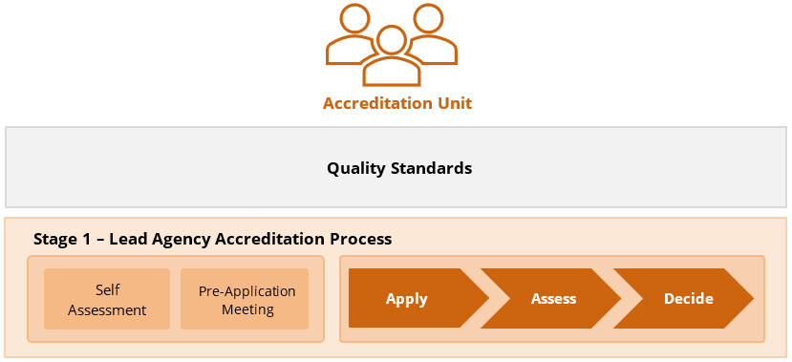

Figure 1: Stage 1 Lead Agency Accreditation Process
How to Complete the Accreditation Application
When completing the Accreditation Application, please ensure that all sections are addressed in entirety, as incomplete submissions may delay the assessment process and incur unnecessary cost.
Step 1 - Complete Accreditation Application
The Lead Agency is to provide responses to each question within the AP-06 Accreditation Application Form and collate the required supporting evidence.

Step 2 - Internal Lead Agency Approvals
The Lead Agency Chief Executive and the Lead Agency Infrastructure Executive (or equivalent) must approve the application and certify that the responses provided are accurate and reflect the Lead Agency’s capability and capacity to deliver projects in accordance with the Framework. Approvals and compliance certification are formally documented on the cover page of the AP-06 Accreditation Application Form.
Step 3 - Submit Application
The completed AP-06 Accreditation Application Form, including a link to the supporting evidence, is to be sent to the Accreditation Unit. Once submitted, the Accreditation Unit will assess the application in accordance with the Guideline.
Step 4 - Respond to Requests for Information
Where the Accreditation Unit requests additional information, supporting documentation and data must be provided by the Lead Agency to support the assessment process.

Accreditation Application Form will be provided after the Pre-Application meeting with the DIT Accreditation Unit.

