Purpose
The purpose of the Pre-Application Meeting is for the Lead Agency to present its Accreditation Self-Assessment and preliminary supporting evidence to the Accreditation Unit and to discuss any perceived gaps which may prevent accreditation from being granted.
Pre-Application Meeting(s) provide an opportunity for the Lead Agency to address any perceived gaps in the formal application, so that the assessment process can be expedited once lodged.
Scope
Lead Agencies formally seeking accreditation under the Framework must participate in a Pre-Application Meeting with a representative of the Accreditation Unit.
The Pre-Application Meeting, shown in Figure 1, will assist Lead Agencies and the Accreditation Unit in understanding the details of an accreditation application before it is formally lodged.
The Pre-Application Meeting is to ensure both parties gain a good understanding of the accreditation application process before lodgement and confirm that Lead Agencies can demonstrate their capability to mitigate risk to government through relevant certifications and provision of satisfactory evidence.
Multiple Pre-Application Meetings may be required depending on the gaps or areas of concern identified by the Accreditation Unit.
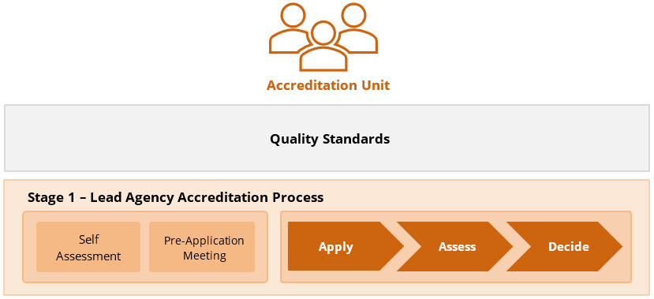
The AP-07 Accreditation Assessment Tool will be used as an agenda by the Accreditation Unit to guide the discussion between the Lead Agency and the Accreditation Unit and to document the outcomes of the meeting.
Figure 1: Stage 1 Lead Agency Accreditation Process

